March 3, 2026
Shannon Niemi
Race Director
2026 BSS Road Races
Bayridge S.S.
1059 Taylor-Kidd Blvd
Kingston, Ontario
K7M 6J9

Phone: 613-389-8932
Email: niemis@limestone.on.ca

Dear Elementary Track and Field Coach / Running Advisor,

Bayridge Secondary School invites your school to participate in the Bayridge Road Races on Tuesday April 28th, 2026. Races will be run rain or shine (or snow), over the roads of Bayridge in Kingston Township. There will be three age groups for elementary boys and girls. Atom 2016 or 2017; Bantam 2014 or 2015; and Senior 2013 or earlier. Medals will be awarded to the top 3 atom, bantam and senior girls and boys in each of the races. Please note that students who identify as non-cisgender, should be registered into the gendered race that best suits their identity. If they are gender fluid and identify differently on race day, please have the athlete compete in the most suitable race and make any changes at registration.

The cost is $3 per student and can be paid by cash or cheque at registration. You only need to pay for the students that compete. Please enter all athletes that you expect to participate as we don’t worry about scratches, but late additions are very time consuming. Please make cheques payable to Bayridge Secondary School. A canteen will be available if students wish to purchase food or drink.

Entries must be sent using the attached excel file to niemis@limestone.on.ca no later than Friday April 24th, 2026 at 4:00pm. Coaches - please enter only the first name (or initial) and last initial of a student whose parent or guardian indicated confidentiality concerns and include a note regarding anyone who may not have their photo released in the media!

*Due to the large number of athletes, coaches and parents attending the races, we ask that anyone associated with the Bayridge Road Races please park in valid parking spaces at BSS and the Church PARKING LOT (not on the grass or along the side/back of the church) or along the streets north of Taylor-Kidd (as permitted). PLEASE PASS ALONG THE MESSAGE THAT ANYONE PARKED IN THE SHOPPER’S DRUG MART LOT, GRASSY or other UNAUTHORIZED AREAS WILL BE TOWED AT THE OWNER’S EXPENSE!

Please see the schedule and map below.

See you at the races!

Shannon Niemi

Bayridge Road Races
Schedule of Events
Tuesday April 28th, 2026
Time | Event | Distance
10:30 am | Registration
11:30 am | Atom Girls | 2 km
12:00 pm | Atom Boys | 2 km
12:30 pm | Bantam Girls | 2 km
12:50 pm | Bantam Boys | 2 km
1:10 pm | Senior Girls | 2.9 km
1:40 pm | Senior Boys | 2.9 km
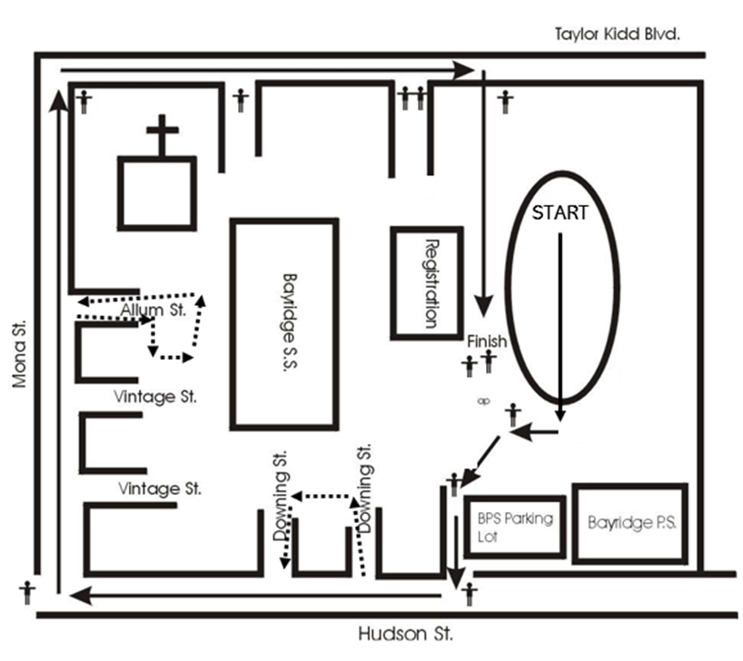
**Senior races run along Downing Street and Allum Street. Both of which are crescents and return to Hudson and Mona respectively.

